# No SQL (Restaurant Database )

**Question**

**(Week-10)**

1. Write a MongoDB query to display all the documents in the collection restaurants.

2. Write a MongoDB query to arrange the name of the restaurants in descending order along with all the columns.

3. Write a MongoDB query to find the restaurant Id, name, town and cuisine for those restaurants which achieved a score which is not more than 10.

4. Write a MongoDB query to find the average score for each restaurant.

5. Write a MongoDB query to find the name and address of the restaurants that have a zip code that starts with '10'.

# 

**Create Table**

db.**createCollection**("Restaurant");

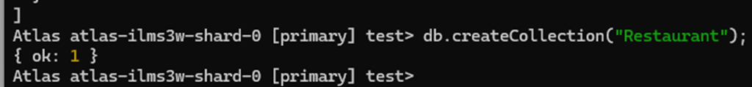

**Inserting values into table**

db.restaurants.insertMany([{ name: "Meghna Foods", town: "Jayanagar", cuisine: "Indian", score: 8, address: { zipcode: "10001", street: "Jayanagar“ } });

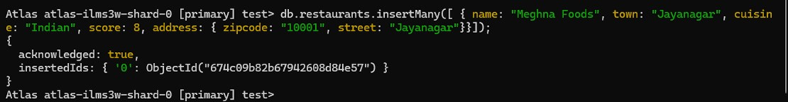

db.restaurants.insertMany([{ name: "Empire", town: "MG Road", cuisine: "Indian", score: 7, address: { zipcode: "10100", street: "MG Road" } }]);

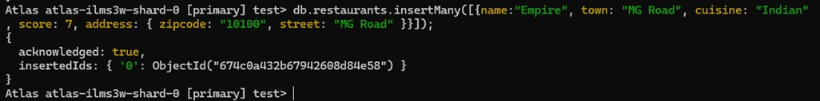

db.restaurants.insertMany([{ name: "Chinese WOK", town: "Indiranagar", cuisine: "Chinese", score: 12, address: { zipcode: "20000", street: "Indiranagar" } }]);

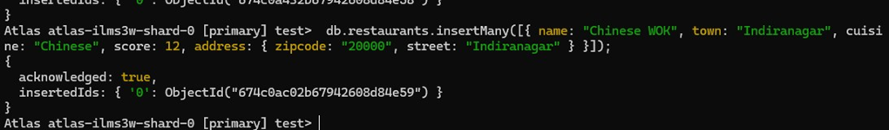

db..restaurants.insertMany([{ name: "Kyotos", town: "Majestic", cuisine: "Japanese", score: 9, address: { zipcode: "10300", street: "Majestic" } }]);

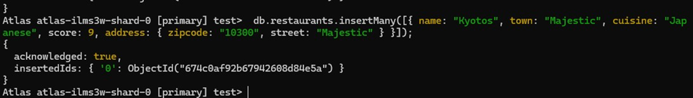

db.restaurants.insertMany([{ name: "WOW Momos", town: "Malleshwaram", cuisine: "Indian", score: 5, address: { zipcode: "10400", street: "Malleshwaram" }} ]);

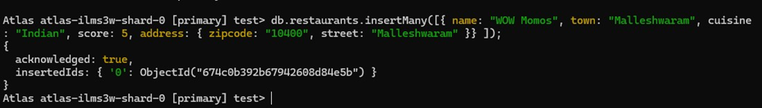

**Queries**

db.restaurants.find({});

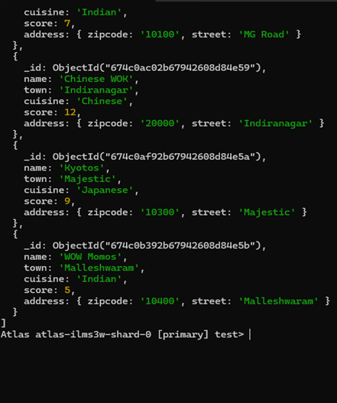

### Query to arrange the name of the restaurants in descending along with all the columns.

db.restaurants.find({}).sort({ name: -1 });

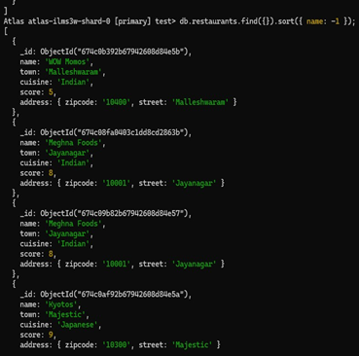

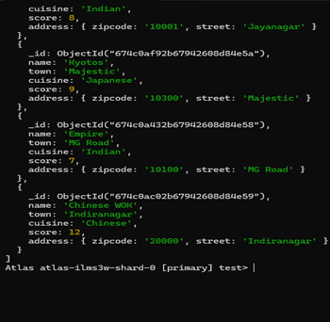

### Query to find the restaurant Id, name, town and cuisine for those restaurants which achieved a score which is not more than 10

db.restaurants.find({ "score": { $lte: 10 } }, { _id: 1, name: 1, town: 1, cuisine: 1 });

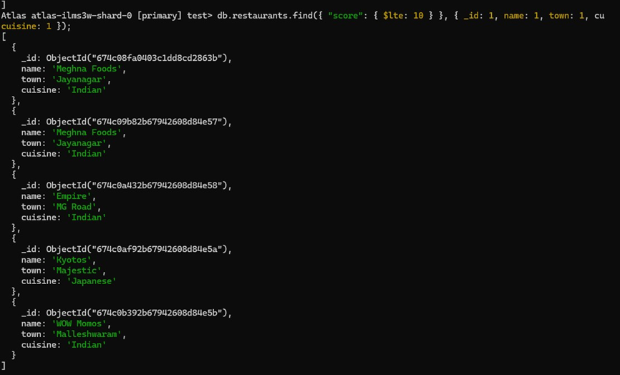

### Query to find the average score for each restaurant

db.restaurants.aggregate([ { $group: { _id: "$name", average_score: { $avg: "$score" } } } ]) ;



 